PROPOSAL FORM FOR AIRCRAFT HULL/LIABILITIES INSURANCE

(Definite answers should be given for all questions. No column should be left blank or completed with a “—“ dash.)

- Proposer’s Name in Full: _______________________________________________________________

- Proposer’s Address:___________________________________________________________________

___________________________________________________________________

- Proposer’s Business/Occupation: ________________________________________________________

- Details of Aircraft to be insured

 |  | AIRFRAME
 |  |  | PASSENGER SEATING |  |  |  | ENGINE
 |  |  | CAPACITY
Make, Type | Year of |  | Licensed | Declared | Registration/ | No. & Date | No. | & | Maximum All-up
& Series | Construction |  |  | for the | Identification | of | Type |  | Weight of Aircraft
No. |  |  |  | Purpose of | Marks | Issue of last |  |  | in Kgs.
 |  |  |  | this |  | C of A
 |  |  |  | Insurance

- Value of the Aircraft

Year of | Price Paid | Present Value of | Extra | Total Value of the Aircraft for
Purchase |  | Aircraft with standard | equipment/accessories | the purpose of Insurance
 |  | instruments & | fitted to or carried in
 |  | Equipment | the Aircraft
 | Rs. | Rs. | Rs. | Rs.
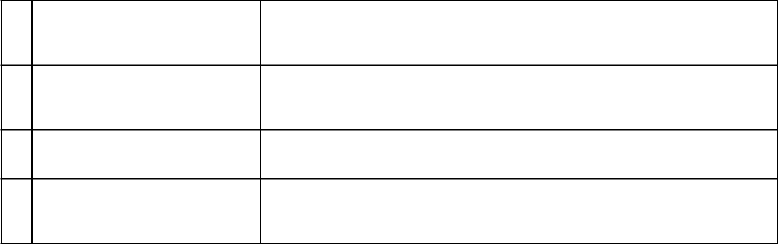

- Purpose for which the Aircraft shall be used.

- Geographical Limits for which Cover is required.

- Will the Aircraft be flown at night?

- By whom will maintenance and running repairs be carried out?

…2

AVG-21(Amended)

2


- (a) Where will the aircraft usually be kept?

  - Is the aircraft normally kept in a hangar?

  - If so, state type and construction of hangar

- Will the aircraft be taxied by persons other than licensed pilots or competent licensed engineers?

- Have you entered into any agreement with any party whereby liability is assumed or denied in respect of the operations of the aircraft?
If so, give details.

- Is there a Lease or Finance
agreement involving this aircraft? If YES, please give brief particulars.

- Has any insurance company at any time:-

  - Declined your insurance proposal?

  - Cancelled or refused to renew your policy?

  - Require an increased premium or imposed any special condition?

If answer to any of above is
“Yes”, please give details.

Has this aircraft been insured

- earlier? If YES,

  - Name of Insurer

  - Period of Insurance

Is this aircraft insured under any

- other policy currently? If YES,

  - Name of Insurer

  - Period of Insurance

AVG 21 (Amended)

…3

3

- Please state details of all accidents/losses to this or any other aircraft owned/operated by you during last 5 years.

Date of Accident | Brief Details of Accident | Cost of/Estimate of | Amount of Liability Claims Incurred
 |  | Repairs to Aircraft(s)
 |  |  | Third Party | Passenger

- Please give details of Pilots who will fly this Aircraft.
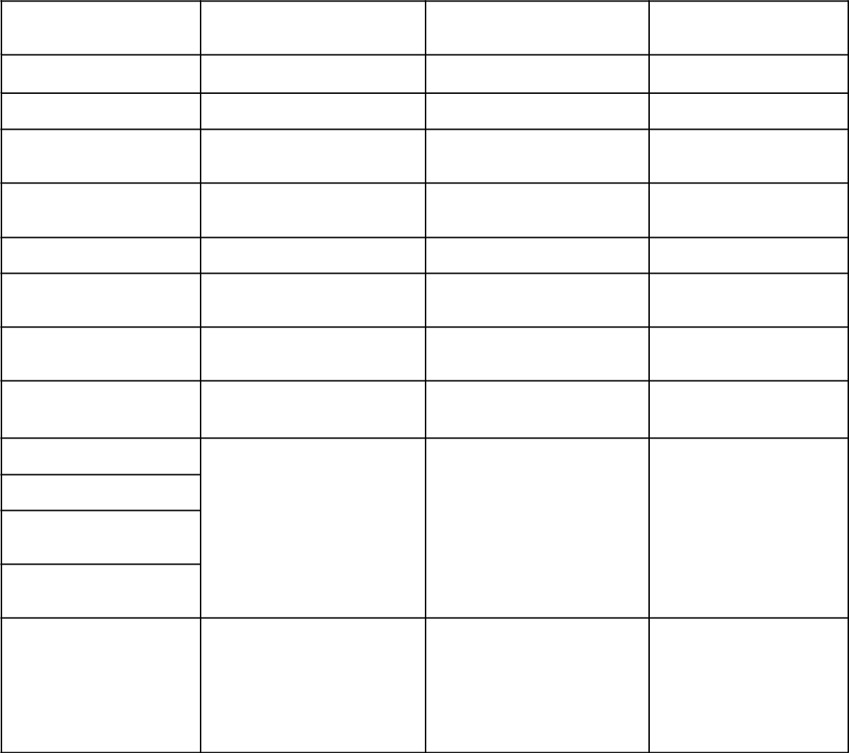

Pilot | Pilot | Pilot

Name:

Age:

Types of Aircraft
Flown

Flying Experience

(in Hours) Total:

Day Hours:

Night Hours:

Total During Last 3
Months:

Hours on type & Make of
Aircraft Now Proposed
for insurance

Current License

Number:

Date of Expiry:

Classification:

Details of Accidents (if
any) during last 3 years.

AVG-21 (Amended)

…4

4

19. Details of Insurance required.

(A) SECTION I – LOSS OR DAMAGE TO THE AIRCRAFT

Whether this Cover is Required

:

If so, risks to be covered (State “Flight”, “Taxiing”, “Ground” and/or “Moored” as the case may be.

:

(B) SECTION II – THIRD PARTY LIABILITY

Whether this Cover is Required

If so, Limit of Indemnity (Any One Accident)

:

:

(C) SECTION III – PASSENGER LIABILITY

Whether this Cover is required.

:

If so, Limit of Liability Per Passenger

:

Whether Cover is required on “Legal Liability” basis or “Admitted Liability” (voluntary settlement) basis?

:

SECTION III – BAGGAGE LIABILITY

Whether this Cover is required

:

If so, Limit of Indemnity per Passenger

:

20. (a) Do you require Hull War Risks Cover?

:

- If full Hull War Risks cover is not required, do
you require limited coverage for Malicious Damage/ |  | :
Strikes, riots & Civil Commotion?Sabotage/
Hijacking?
21. | Period of Insurance now required | : From______________To___________________
22. | Any other material information | :

I/We warrant that the above mentioned aircraft is/are my/our property and that the statements and particulars given are true and that no material information has been withheld or suppressed and I/we agree that (a) this proposal and declaration shall be the basis of the contract between me/us and the insurance company and to

accept a Policy subject to terms, conditions and exclusions prescribed therein; (b) non-disclosure or incomplete disclosure of any fact which is or may be material to the insurance company in deciding whether to accept my/our proposal for insurance shall invalidate the policy and causeme/us to be deprived of all benefits thereunder; (c) the insurance company reserves the right to impose special conditions or refuse to accept a proposal form.

Place:

Date:

________________________________

Signature of the Proposer

Name & Desig.

AVG-21(Amended)

